training 1 epoch...

84.82688188552856 seconds used......

1 training finished! average train loss: 0.641832266917877

total clf loss: 150.53113900125027 total adv loss: 83.86763305217028

evaluating...

Confusion matrix, without normalization

[[ 226 39 29]

[ 782 2889 150]

[ 36 16 790]]

Normalized confusion matrix

[[0.76870748 0.13265306 0.09863946]

[0.20465847 0.75608479 0.03925674]

[0.04275534 0.01900238 0.93824228]]

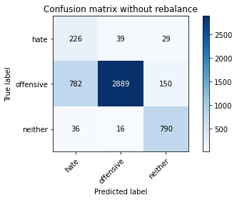

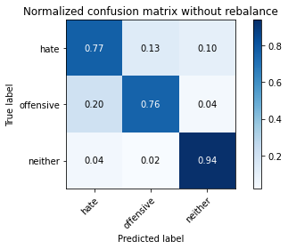

precision recall f1-score support

hate 0.22 0.77 0.34 294

offensive 0.98 0.76 0.85 3821

neither 0.82 0.94 0.87 842

accuracy 0.79 4957

macro avg 0.67 0.82 0.69 4957

weighted avg 0.91 0.79 0.83 4957

average eval_loss: 0.4576628181149232, accuracy: 0.7877748638289288

training 2 epoch...

84.10236263275146 seconds used......

2 training finished! average train loss: 0.3691376588519728

total clf loss: 86.78596945852041 total adv loss: 52.451665945351124

evaluating...

Confusion matrix, without normalization

[[ 230 53 11]

[ 614 3137 70]

[ 61 42 739]]

Normalized confusion matrix

[[0.78231293 0.18027211 0.03741497]

[0.16069092 0.82098927 0.01831981]

[0.07244656 0.04988124 0.87767221]]

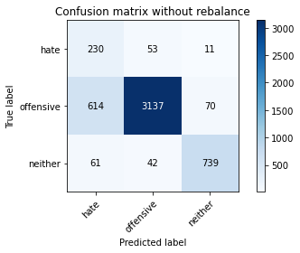

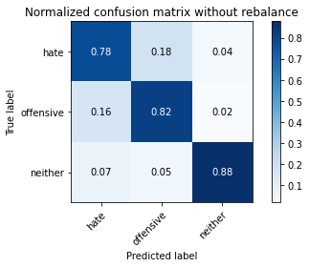

precision recall f1-score support

hate 0.25 0.78 0.38 294

offensive 0.97 0.82 0.89 3821

neither 0.90 0.88 0.89 842

accuracy 0.83 4957

macro avg 0.71 0.83 0.72 4957

weighted avg 0.92 0.83 0.86 4957

average eval_loss: 0.4087461071072028, accuracy: 0.8283235828121848

training 3 epoch...

84.05861020088196 seconds used......

3 training finished! average train loss: 0.25094589238104065

total clf loss: 59.28240944817662 total adv loss: 41.33492031227797

evaluating...

Confusion matrix, without normalization

[[ 249 35 10]

[ 985 2759 77]

[ 111 30 701]]

Normalized confusion matrix

[[0.84693878 0.11904762 0.03401361]

[0.25778592 0.72206229 0.02015179]

[0.13182898 0.03562945 0.83254157]]

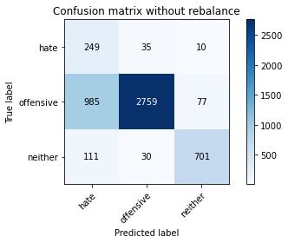

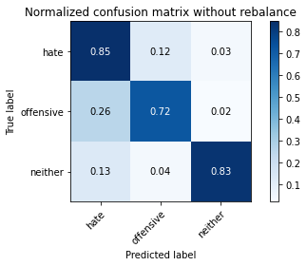

precision recall f1-score support

hate 0.19 0.85 0.30 294

offensive 0.98 0.72 0.83 3821

neither 0.89 0.83 0.86 842

accuracy 0.75 4957

macro avg 0.68 0.80 0.66 4957

weighted avg 0.92 0.75 0.80 4957

average eval_loss: 0.6028466017697333, accuracy: 0.7482348194472463

training 4 epoch...

84.16964149475098 seconds used......

4 training finished! average train loss: 0.16389500734951803

total clf loss: 38.87344601564109 total adv loss: 30.10768531449139

evaluating...

Confusion matrix, without normalization

[[ 254 30 10]

[1104 2632 85]

[ 101 22 719]]

Normalized confusion matrix

[[0.86394558 0.10204082 0.03401361]

[0.2889296 0.68882491 0.02224549]

[0.11995249 0.02612827 0.85391924]]

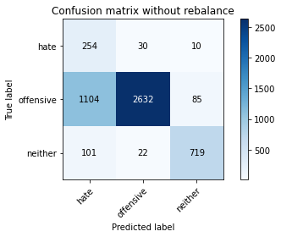

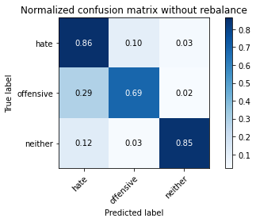

precision recall f1-score support

hate 0.17 0.86 0.29 294

offensive 0.98 0.69 0.81 3821

neither 0.88 0.85 0.87 842

accuracy 0.73 4957

macro avg 0.68 0.80 0.66 4957

weighted avg 0.92 0.73 0.79 4957

average eval_loss: 0.7418937311955134, accuracy: 0.7272543877345169

training 5 epoch...

84.07756686210632 seconds used......

5 training finished! average train loss: 0.11042221299405292

total clf loss: 26.257160149049014 total adv loss: 21.617911988985725

evaluating...

Confusion matrix, without normalization

[[ 233 40 21]

[ 901 2792 128]

[ 56 11 775]]

Normalized confusion matrix

[[0.79251701 0.13605442 0.07142857]

[0.23580215 0.73069877 0.03349908]

[0.06650831 0.01306413 0.92042755]]

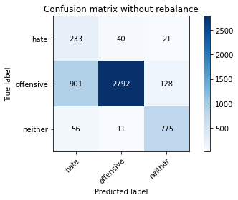

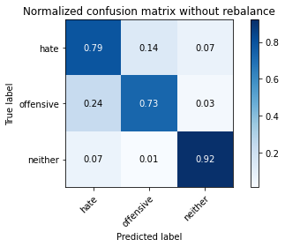

precision recall f1-score support

hate 0.20 0.79 0.31 294

offensive 0.98 0.73 0.84 3821

neither 0.84 0.92 0.88 842

accuracy 0.77 4957

macro avg 0.67 0.81 0.68 4957

weighted avg 0.91 0.77 0.81 4957

average eval_loss: 0.7603439061151215, accuracy: 0.7665926971958846

training 6 epoch...

84.15314769744873 seconds used......

6 training finished! average train loss: 0.08231062295830302

total clf loss: 19.522907877340913 total adv loss: 15.121715730259893

evaluating...

Confusion matrix, without normalization

[[ 223 47 24]

[ 789 2879 153]

[ 31 21 790]]

Normalized confusion matrix

[[0.7585034 0.15986395 0.08163265]

[0.20649045 0.75346768 0.04004187]

[0.0368171 0.02494062 0.93824228]]

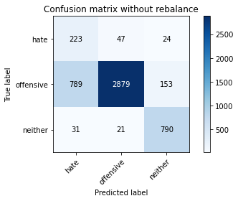

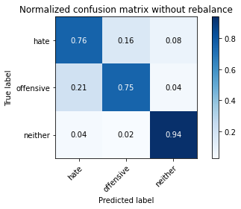

precision recall f1-score support

hate 0.21 0.76 0.33 294

offensive 0.98 0.75 0.85 3821

neither 0.82 0.94 0.87 842

accuracy 0.79 4957

macro avg 0.67 0.82 0.69 4957

weighted avg 0.90 0.79 0.82 4957

average eval_loss: 0.8014765616613257, accuracy: 0.7851523098648376

training 7 epoch...

84.05464220046997 seconds used......

7 training finished! average train loss: 0.05214414024560124

total clf loss: 12.41667453548871 total adv loss: 10.55621122424418

evaluating...

Confusion matrix, without normalization

[[ 236 36 22]

[1053 2648 120]

[ 60 20 762]]

Normalized confusion matrix

[[0.80272109 0.12244898 0.07482993]

[0.27558231 0.6930123 0.03140539]

[0.07125891 0.02375297 0.90498812]]

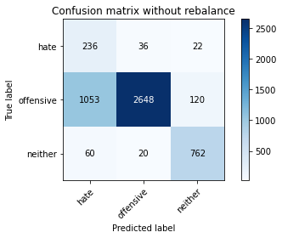

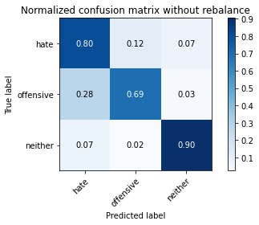

precision recall f1-score support

hate 0.17 0.80 0.29 294

offensive 0.98 0.69 0.81 3821

neither 0.84 0.90 0.87 842

accuracy 0.74 4957

macro avg 0.67 0.80 0.66 4957

weighted avg 0.91 0.74 0.79 4957

average eval_loss: 1.0664177615754025, accuracy: 0.7355255194674198

training 8 epoch...

84.46477723121643 seconds used......

8 training finished! average train loss: 0.020279670620782366

total clf loss: 4.922972840664443 total adv loss: 5.984157798389788

evaluating...

Confusion matrix, without normalization

[[ 217 54 23]

[ 641 3103 77]

[ 47 45 750]]

Normalized confusion matrix

[[0.73809524 0.18367347 0.07823129]

[0.16775713 0.81209108 0.02015179]

[0.05581948 0.05344418 0.89073634]]

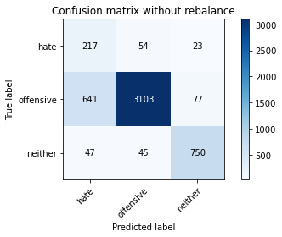

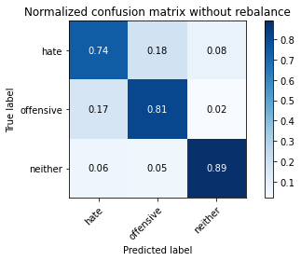

precision recall f1-score support

hate 0.24 0.74 0.36 294

offensive 0.97 0.81 0.88 3821

neither 0.88 0.89 0.89 842

accuracy 0.82 4957

macro avg 0.70 0.81 0.71 4957

weighted avg 0.91 0.82 0.85 4957

average eval_loss: 0.7794442506615366, accuracy: 0.8210611256808553

training 9 epoch...

84.06414198875427 seconds used......

9 training finished! average train loss: 0.04333846325569443

total clf loss: 10.315080436994322 total adv loss: 8.678216111900838

evaluating...

Confusion matrix, without normalization

[[ 206 76 12]

[ 440 3323 58]

[ 75 63 704]]

Normalized confusion matrix

[[0.70068027 0.2585034 0.04081633]

[0.1151531 0.86966763 0.01517927]

[0.08907363 0.07482185 0.83610451]]

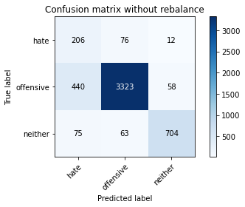

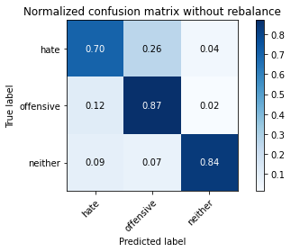

precision recall f1-score support

hate 0.29 0.70 0.41 294

offensive 0.96 0.87 0.91 3821

neither 0.91 0.84 0.87 842

accuracy 0.85 4957

macro avg 0.72 0.80 0.73 4957

weighted avg 0.91 0.85 0.88 4957

average eval_loss: 0.6975717180720854, accuracy: 0.8539439176921525

training 10 epoch...

84.36297726631165 seconds used......

10 training finished! average train loss: 0.03367190053247389

total clf loss: 8.146686771302484 total adv loss: 9.3898695386888

evaluating...

Confusion matrix, without normalization

[[ 209 60 25]

[ 595 3062 164]

[ 36 19 787]]

Normalized confusion matrix

[[0.71088435 0.20408163 0.08503401]

[0.1557184 0.8013609 0.0429207 ]

[0.04275534 0.02256532 0.93467933]]

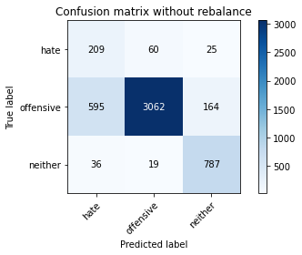

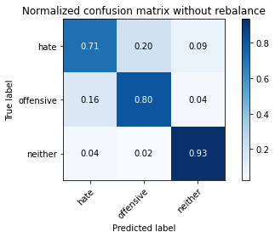

precision recall f1-score support

hate 0.25 0.71 0.37 294

offensive 0.97 0.80 0.88 3821

neither 0.81 0.93 0.87 842

accuracy 0.82 4957

macro avg 0.68 0.82 0.70 4957

weighted avg 0.90 0.82 0.85 4957

average eval_loss: 0.8427438911249625, accuracy: 0.8186403066370789